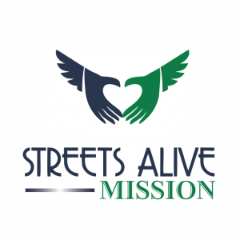
JOB DESCRIPTION
Streets Alive Family Support Association

Title: Program Coordinator Supervisor: Manager, Genesis/Exodus

General Summary:

Under the direction of, and in collaboration with the Manager of Genesis or Exodus Programs, this position is responsible to oversee the delivery of the broad spectrum of services that are relevant to Streets Alive Mission and the Recovery Road Program.

Qualifications and Skills:

- Enjoy meeting new people and building relationships; be willing to share personal stories and history to connect with those we serve.
- Knowledge and understanding of people in addiction/dependency, homelessness, mental health issues and poverty.
- Excellent people manager, open to direction and collaborative work style, with a commitment to get the job done.
- Ability to plan, organize and handle multiple tasks simultaneously and to delegate tasks and accept responsibilities effectively.
- Be detail oriented and able to work with little supervision, and in cooperation with the other Directors for the betterment of the Association and its residents.
- Must be able to analyze the needs of our resident base, and develop, institute and deliver services to meet the needs identified.
- Must be able to communicate clearly and courteously, verbally and in writing with strong organizational, interpersonal and presentation skills.
- Experience and education in the field of Addictions or Ministry are a definite asset.
- Valid Driver’s License

Duties, Responsibilities & Expectations:

- Provide effective and inspiring leadership, as well as stewardship and accountability to Streets Alive Mission staff by being actively involved in all resident-related programs and services.
  - Have a thorough understanding of all programs offered by Streets Alive Mission and a willingness to be involved in all programs.
- To continuously analyse and evaluate all resident-related programs and services, ensuring they meet the physical, emotional and spiritual needs of the residents seeking help from the Streets Alive Mission Recovery Road Program and introducing activities and programs specific to needs of Streets Alive Mission Recovery Road Program.
- To manage the resources of the delivery of resident services, ensuring that adequate materials and supplies are on hand and that all facilities and equipment are maintained and repaired in an appropriate manner.
- To actively participate in daily devotions and weekly team meetings.
- To enforce rules and regulations of the homes, including administering random drug tests and overseeing room searches in collaboration with the RHCs.
- Take residents in the Program to court dates, medical appointments and meetings as needed from time to time. Use this time for on-on-one discussions and mentoring as appropriate.
- To take on any other work or projects as assigned by the Manager of Genesis or Exodus.
- To be an example, and provide appropriate leadership, to staff, and residents in the Program.
- To serve as a mentor to staff members, as needed.
- Criminal record check
- Drivers Abstract

Hours and Benefits:

- Hours: Average 40 hours per week. Work outside normal business hours is expected.
- Leave, Holidays, and benefits as described in the Employee Handbook.

Created: Dec. 31/19 Reviewed: Mar 25/25 Approved by: ELT

